Your PTFA School Year 2018/2019

What an amazing fundraising year we’ve had! We have raised a total of £8,558 this year from the following events:

- Christmas Cinema Afternoon - £153
- Christmas Wreath making - £472
- Christmas Raffle - £205
- Secret Santa Shop - £231
- Smartie Tube Challenge - £80
- Colour Run - £820
- Cookbook - £385
- Summer Fair - £817
- Sally Wainwright Evening - £3,135
- Gift Aid Claim - £266
- Monthly Standing Order Donations - £1,900
- Various others - £94

The PTFA would like to say a huge THANK YOU to everyone who has helped to raise this money from organising, volunteering and supporting these events. We couldn’t have done it without you!

We would like to give our appreciation to the Parents who send in a monthly standing order donation every month. Thank you so much as we would not be able to run the PTFA effectively without it.

A shout out of recognition goes to; Hartleys Bakery, Evolve Fitness & Physio, The Beauty Clinic at Bolton Brow, Zikodrive Motor Controllers, Ovenden Football Club, Calderdale Kettlercise, Lloyds Banking Group, Far Barsey Farm Shop, The Hobbit, The Spring Rock, Just Jenny’s Ice Cream, Cobblestones, Little Lenny Company, The Glass Slipper in Ripponden, who have all contributed to this success with their support and charity.

At meetings throughout the year it was agreed to allocate funds to the following:
- Replacing Classroom Whiteboards
- Coach fares for school trips
- Santa Book Gifts
- Complete construction of a new Outdoor Learning Area.

In addition, we welcomed Reception parents and children with a Gingerbread handout and we filled 10 Rotary Club boxes at Christmas.
The AGM meeting will be held on Tuesday 10 September where we will be deciding on next year’s events. Please come along and support your PTFA. Every penny counts towards improving the children’s opportunities and experiences at school.

Don’t forget to bring into school any lightly worn school uniform for the Recycled Uniform Sale on Monday 15 & Tuesday 16 July for the sale to be held after school on Thursday 18 July. Many thanks!

Don’t forget to follow us on Facebook at Norland CE PTFA

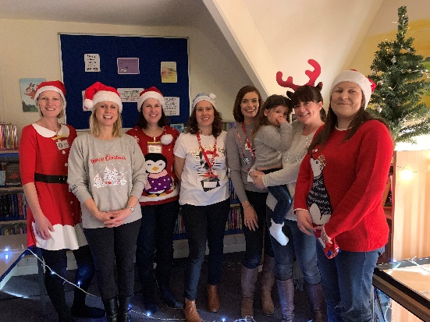
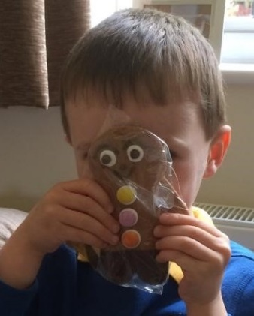
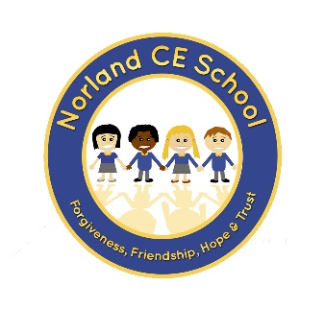
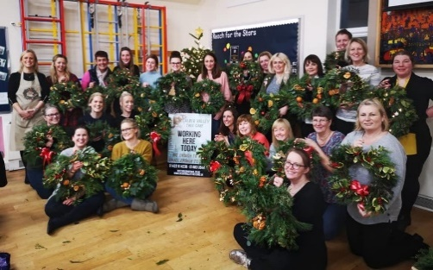
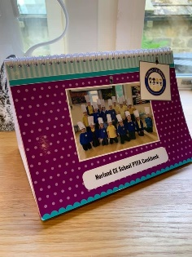
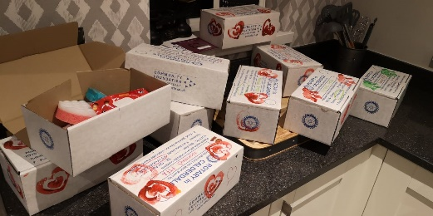
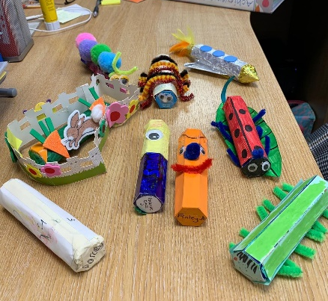
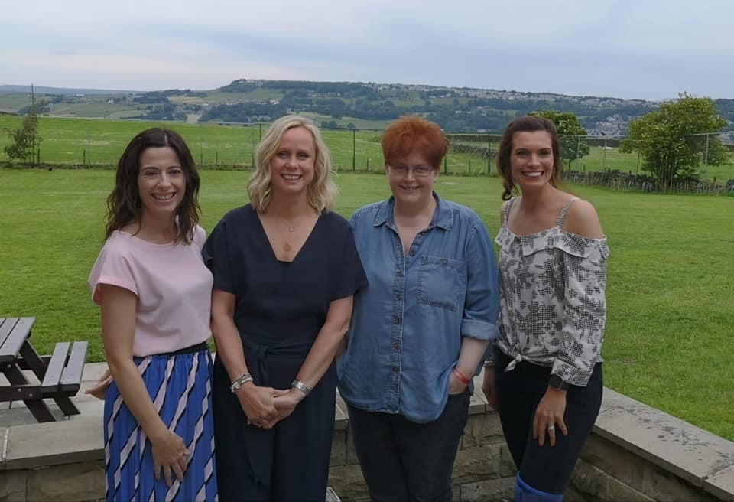
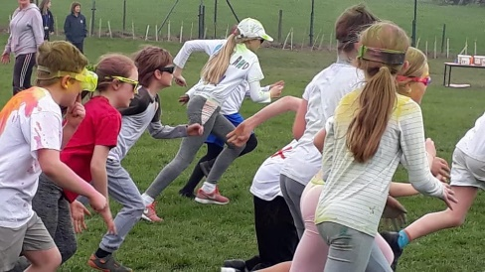
2018-2019
Money raised:
£8,558

