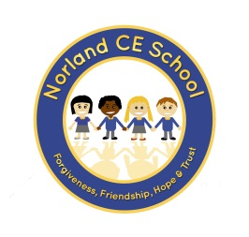

School Newsletter – 7th October 2020
Dear Parents and Carers

Parent Governors
Please make sure you take the time to vote for a School Governor. We have 3 applications across the two schools and only 2 vacancies. If you need a ballot form, please ask at the office. Please make sure your vote is with the returning officer no later than noon on Friday this week. debby.simpson@calderdale.gov.uk

School Administrator
We are very pleased to welcome Mrs Fiona Simeunovich to the Norland School family. Mrs Simeunovich will be helping in the office on Mondays, and Tuesday and Thursday afternoons.

Poppy Appeal
We understand many things are a little different this year but we are very pleased to say that we will still be supporting the Royal British Legion by helping with their annual Poppy Appeal. We have poppies on sale in school along with the usual box of ‘child friendly’ poppy related items you can purchase. We have coat reflectors with a suggested donation of 50p, coat tags at 50p, wrist bands for £1 and ‘slap it’ rulers for £1.50.
If you or your child would like to purchase anything, please send them with some money in a named envelope. Many thanks for your support with this very worthy cause.

Home Learning
In school, we are busy setting up a new platform with enhanced interactivity to ensure your child can continue to learn and keep up with school work if they are required to spend any time at home. This is called Google classrooms and it is nearly operational; full details and guidance will be sent home shortly. It will ensure that your child can continue to learn and access the work that is going on in school so they maintain the ‘catch-up’ that has started following the summer term lockdown. Please bear with us as we establish this, it’s a learning curve for us all!

In the meantime, teachers are continuing to put work on the ‘Learn Button’ accessed from our school website and reading books (allocated by the teacher) are available electronically too at https://www.activelearnprimary.co.uk/login?c=0.
Your class teacher will send you log in details if you are new to school.

Many thanks for your continued support
With very best wishes,

Ali Oliver

