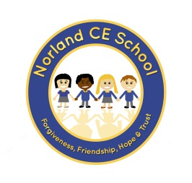

School Newsletter – 15th October 2020
Dear Parents and Carers

Parent Governors
Thank you all for taking the time to vote for your Parent Governors. We are pleased to let you know that Mrs Shelley Bates and Mr Ben Green were elected.

Poppy Appeal
Don’t forget we are selling poppies and other items in school. We have coat reflectors with a suggested donation of 50p, coat tags at 50p, wrist bands for £1 and ‘slap it’ rulers for £1.50.
If you or your child would like to purchase anything, please send them with some money in a named envelope. Many thanks for your support with this very worthy cause.

Class 1
After half term we will be saying goodbye to Mrs Allen who has decided to resign from her post after many years of service due to personal reasons. We wish Mrs Allen the very best with her new adventures. We will be advertising for a new Teaching Assistant and hope to make a new appointment very soon.

Home Learning
This weekend your child should have had some work set on their new Google Classroom which they can access from home. If anyone has any difficulty in accessing the ‘classroom’, please speak to your class teacher who will be happy to help.

We are now coming to the end of our first half term in school. Well done to everyone for keeping positive and working so hard. Usually we would hold a parents’ evening very soon but due to COVID restrictions, Public Health England will not allow parents into school at this time. We would normally let you know how your child has settled into school and update you on what we have been doing in class. We are very pleased with the way children have settled in and we are very proud of how well they have learnt our new routines. Your class teacher will telephone you for a short update during the 1st two weeks back after half term. However, should you have any concerns about your child, please do contact your class teacher in the first instance to address this. Many thanks for your support.

Reminder: School is closed next week for half term and reopens to pupils on Tuesday 3rd November.

Many thanks for your continued support.
With very best wishes,

Ali Oliver

