6th March 2018

Dear Parents / Carers

Re: Application to join Trinity MAT

You may recall that we previously advised you that the Governing Body of Norland School were investigating the possibility of joining the Trinity MAT. After much consideration, the governors have decided that this is not the best option for our school at this time.

We are still looking into other possibilities for our school and will keep you informed of any future developments.

If you have any questions, please contact Mrs Clayton.

Best Regards

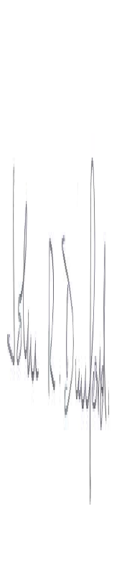
Dr John Dunford
Chair of Governing Body

